 | Abdi İpekçi Caddesi Kaşıkçıoğlu Apt. No:42 D:2 34365 Nişantaşı İstanbul  www.artxist.com  info@artxist.com  T. +90 212 291 77 84 F. +90 212 343 69 35 | PRESS RELEASE

“DISGUISE”

“I snatched the kids that theirs moms call "my pasha" in order to keep them in a sheltered place.”

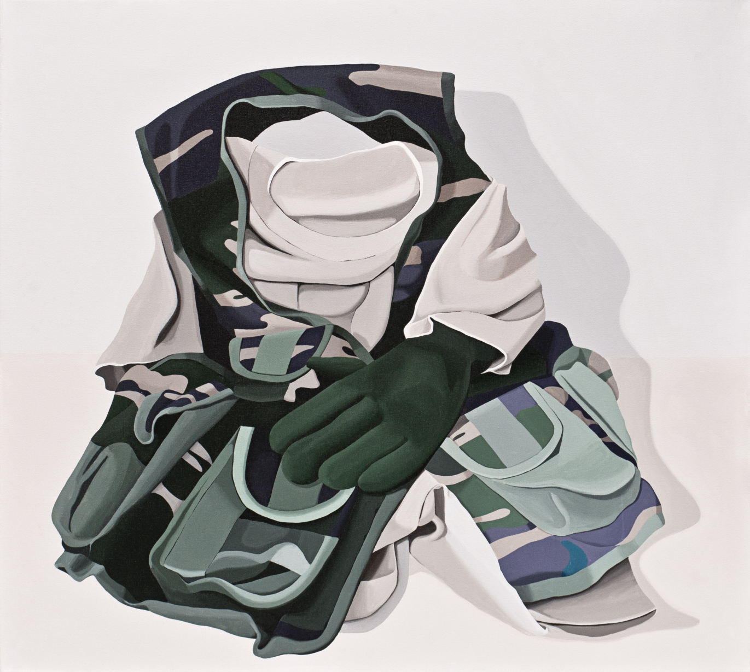

Seda Hepsev, At Ease and Attention, Acrylic on canvas, 80 x 90 cm, 2012

Seda Hepsev will be on view at x-ist with her fourth solo exhibition ‘Disguise’ from January 24 to February 23, 2013. ‘Disguise’, which means ‘to change and conceal identity’ in English, aims to question the military service that is seen as a mandatory stop towards the destination of manhood, just like male circumcision and the very first sexual experience are.

The abundance of the signboards that read “every kind of kid’s military clothing up to the age of 10 is available” and the pride that the parents of the kids in those outfits have, are the premature representations of the military service which is a ritual for stepping into manhood.

While representing a transitional space that is detached from life, the lifestyles and uniforms that are worn throughout the military service, which is a mandatory stop due to Turkey’s political structure and religious beliefs and saves men a social rank and authorization, lose their authenticity and validity once the military service is over.

The exhibition, which addresses the similarity between the military service and other foundations of power such as school and family and the reproduction of the identity of man in this context of sovereignty established by fellow men, is composed of four parts complementing each other.

The first part is composed of paintings depicting hollow military uniforms. The pieces of military uniforms that are side by side, one under the other, so thrown, or consciously taken off come together in different compositions on 15 canvases. Right across these paintings, there is another piece made by “patchwork” technique using the real military fabric depicted in the paintings mentioned above.

The second part of the exhibition is composed of three canvas paintings originated from the movie, “Top Gun”. They depict the inclusion of the leading actor and his outfits into our lives in 1980s, and refresh the space that the image of an American soldier has in our memory.

The drawings that depict figures making towers out of humans constitute the third part of the exhibition. In these drawings made with a technique that is mostly used by kids in which color pastels are covered with a black paint and then scratched, the shows that represent power and endurance are depicted with thin and colorful contours.

Finally in the last part, there are pieces which bring military outfits, fabrics, and accessories together in different compositions and reproduce them. The objects and drawings that represent the military as an institution which exists through instigating the idea of power, violence, and rivalry, exist through repeating themselves just like the continuous reconstruction of male identity.

Artist Biography

SEDA HEPSEV
1978, İstanbul
Graduated from the sufficiency in arts program in 2012, Hepsev had the following exhibitions at x-ist: “Intersection I” (2005), “The Null Element” (2007), “Some Wrongs Do Make a Right” (2008) and “Everyone is a Kid at a Kids’ Birthday Party” (2011). She took place in many international exhibitions and art fairs such as “A new hook. Rethinking Needlework” (Switzerland, 2011), “Istanbul Now” (Vienna, 2007), “Art Dulcinium” (Serbia, 2005), 11th Biennial of Young Artists of Europe and the Mediterranean (Athens, 2003), “İstanbul’s Doors” (Amiens, 1999), “young expansions” (Pera Museum, 2005), Contemporary Istanbul’07, 08, 09, 10 & 11, Start-2009 (14th European Contemporary Art Fair, Strasbourg, France), Vienna Art Fair 2011, Art Beat 2011, VIP Art Fair 2012, SCOPE Basel 2010 & 2012. Hepsev participated in the artist residency program at Cite International des Arts (Paris) in 2011 and also exhibited her work in the group show “Dream & Reality” at The Istanbul Museum of Modern Art (2011 - 2012). Seda Hepsev is featured in the book “Unleashed: Contemporary Art From Turkey” first published in 2010.

Sergi Açılış Sponsoru


